**Kafka Tutorial**

Clone Git Repo

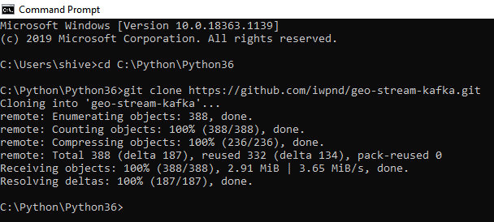

Change Kafka_Advertised_Host_Name as localhost

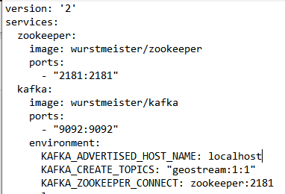

Create .env in geostream

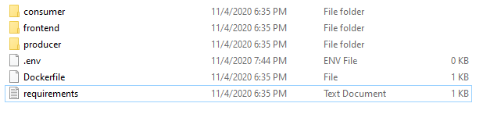

Run docker and use cmd for following command



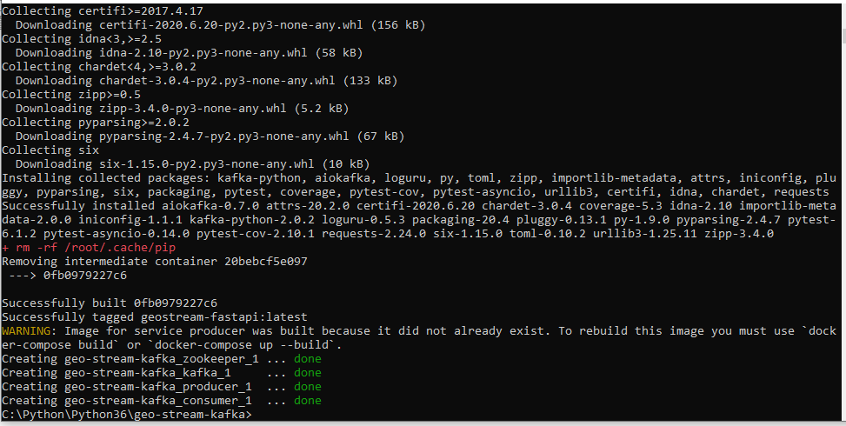

After Completion

